28-4-2020

Καλημέρα παιδιά.
Σήμερα θα μελετήσετε προσεκτικά τα επιρρήματα συχνότητας (adverbs of frequency) από τη σελίδα 32 του βιβλίου του μαθητή ή από το τετράδιο της γραμματικής.
Θυμηθείτε ότι τα επιρρήματα συχνότητας χρησιμοποιούνται με τον απλό ενεστώτα και έχουν συγκεκριμένη θέση μέσα στην πρόταση: πριν από τα κύρια ρήματα αλλά μετά από το ρήμα είμαι (to be) και τα βοηθητικά ρήματα.

% 0

% 100

I usually go to the cinema.
They are sometimes late .
She doesn’t usually eat vegetables.

Adverbs of frequency 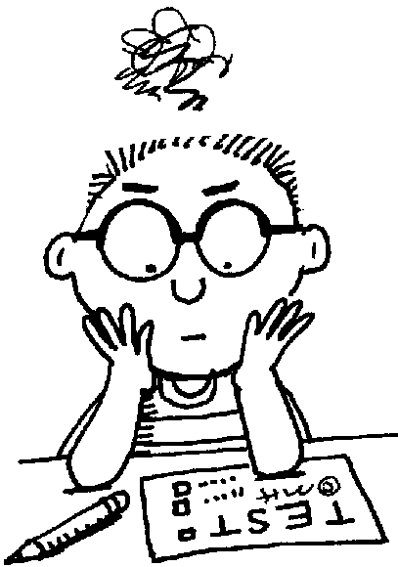

1.Rewrite the sentences using the adverb in brackets in its correct position.

He listens to the radio. (often)
___________________________________________________________
They read a book. (sometimes)
___________________________________________________________
Pete gets angry. (never)
___________________________________________________________
Tom is very friendly. (usually)
___________________________________________________________
I take sugar in my coffee. (sometimes)
___________________________________________________________
Ray and Frank are hungry. (often)
___________________________________________________________
My grandmother goes for a walk in the evening. (always)
___________________________________________________________
Walter helps his father in the kitchen. (usually)
___________________________________________________________
They watch TV in the afternoon. (never)
___________________________________________________________
Christine smokes. (never)
___________________________________________________________

2. Rewrite the sentences in the correct order.

usually - in the morning - reads the newspaper - Tom
___________________________________________________________
He -frequently - is - for class - late
___________________________________________________________
always –they - happy - are
___________________________________________________________
help – she - often - does - her mother?
___________________________________________________________
by 11:30 - is - Ann -always -in bed.
___________________________________________________________
seldom -Molly - museums - visits.
___________________________________________________________
study - you – rarely - for tests.
___________________________________________________________

