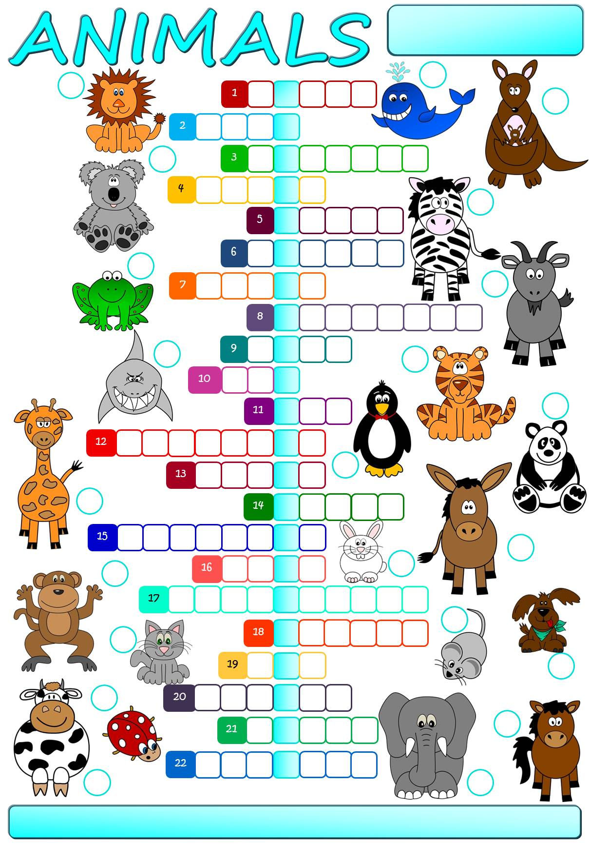
Match the words to the correct pictures and complete the crossword. Then find a secret message.

6
2
cat
cow
dog
donkey
elephant
frog
giant panda
giraffe
goat
horse
kangaroo
koala
ladybird
lion
monkey
mouse
penguin
rabbit
shark
tiger
whale
zebra

1
3
4
5
21
20
7
8
9
10
15
11
12
16
14
22
17
18
19
13
The secret message is _________ __________ _________ _________ ________ ________ summer.

Match the words to the correct pictures and complete the crossword. Then find a secret message.

6
2
cat
cow
dog
donkey
elephant
frog
giant panda
giraffe
goat
horse
kangaroo
koala
ladybird
lion
monkey
mouse
penguin
rabbit
shark
tiger
whale
zebra

1
3
4
5
21
20
7
8
9
10
15
11
12
16
14
22
17
18
19
13
The secret message is _________ __________ _________ _________ ________ ________ summer.

R
N
E
S
W
A
L
L
O
W
D
O
E
S
N
O
T
M
A
K
E
H
S
O
E
I
P
O
Match the words to the correct pictures and complete the crossword. Then find a secret message.

L
N
G
U
O
M
E
E
H
A
B
R
T
A
K
O
B
I
A
D
Y
G
A
P
C
O
R
O
A
G
G
I
H
A
T
E
A
G
R
G
P
I
O
N
E
T
O
D
Z
R
A
A
R
F
F
E
I
G
A
N
C
B
F
N
6
2
cat
cow
dog
donkey
elephant
frog
giant panda
giraffe
goat
horse
kangaroo
koala
ladybird
lion
monkey
mouse
penguin
rabbit
shark
tiger
whale
zebra

B
1
3
4
5
21
20
7
8
9
10
15
11
12
16
14
22
17
K
18
19
13
U
I
N
L
A
D
R
T
N
K
A
T
R
R
K
H
P
L
E
A
N
D
A
Y
Y
E
G
I
The secret message is One swallow does not make a summer.

