Look and fill in with There is,
There are, There isn’t, There aren’t.
________________________ a mirror.
________________________ any rollerblades.
________________________ a TV set.
________________________ some books.
________________________ a paper bin.
________________________ three boxes.
________________________ any curtains.
________________________ a football.
________________________ a schoolbag.
10. _______________________ an armchair.
11. _______________________ some toys.
12. _______________________ a bed.
13. _______________________ two lamps.
14. _______________________ any rubbish.
______________________ a rug?____
______________________ any notebooks?____
______________________ a kite?____
______________________ computer?____
______________________ any posters?____
______________________ a chair?____
______________________ a wardrobe?____
______________________ any pictures?____
______________________ a clock?____
10. _____________________ scooter?____
11. _____________________ any plants?____
12. _____________________ any drawers?____
13. _____________________ a shelf?____
14. _____________________ a teddy?____

Fill in with Is there, Are there and
answer Yes or No.

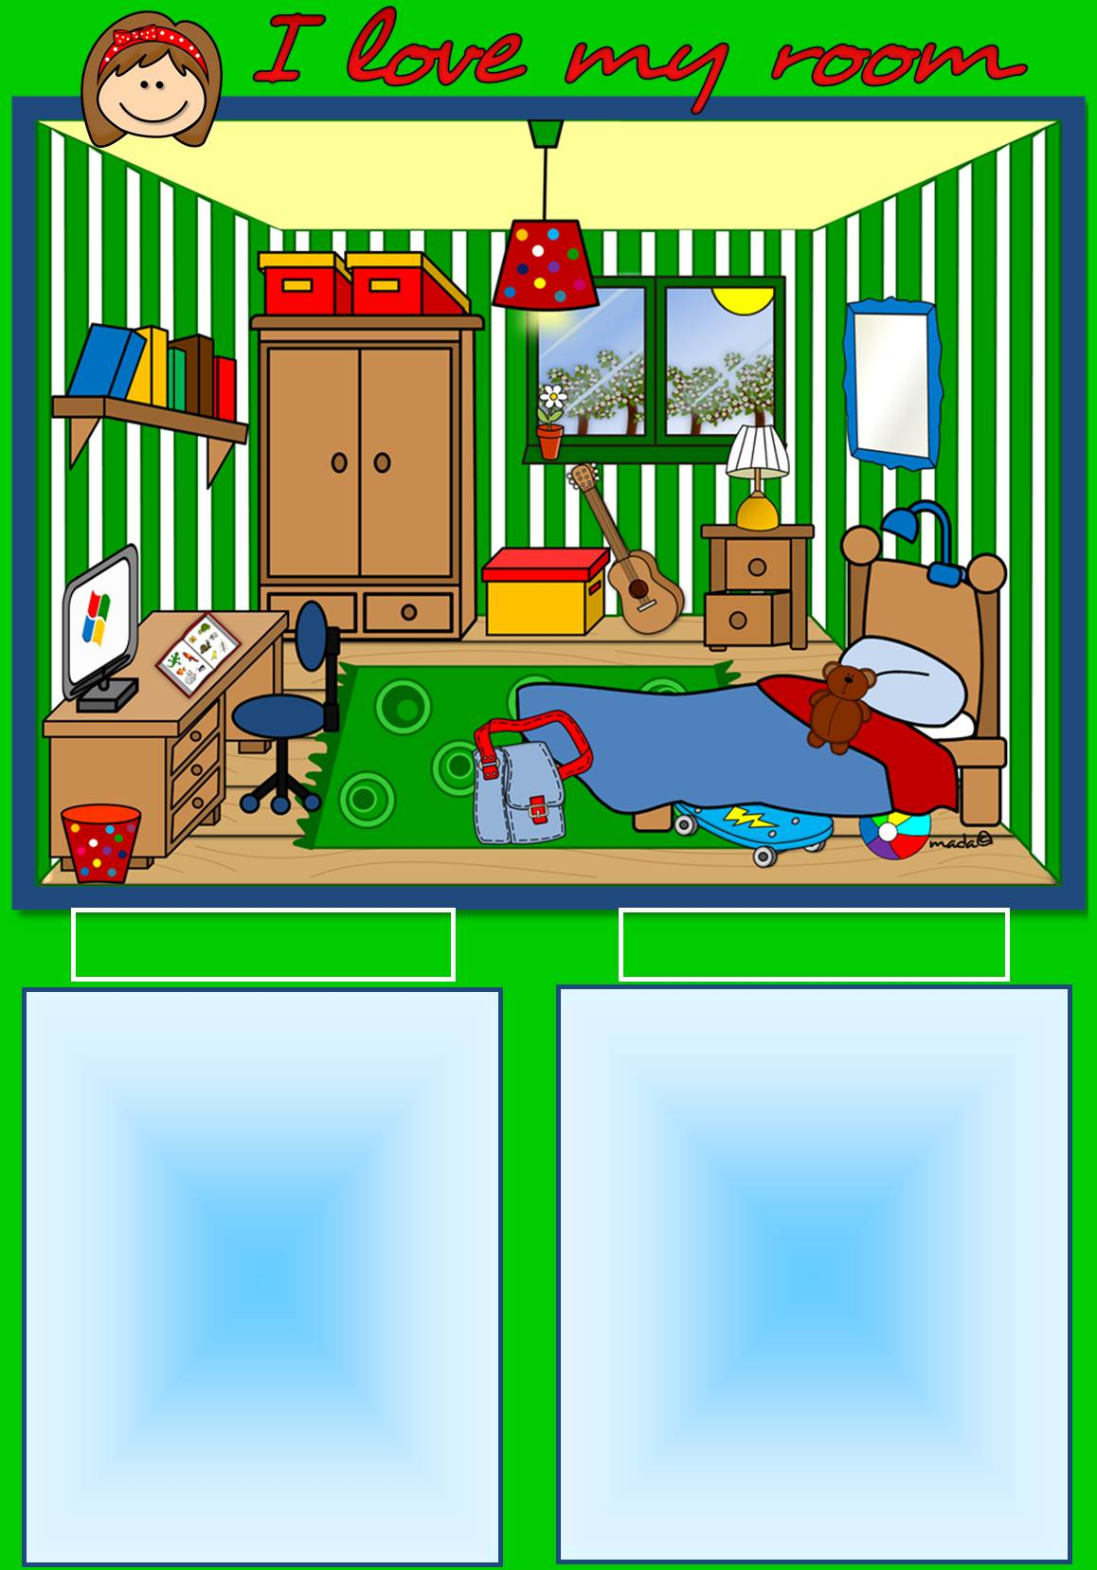

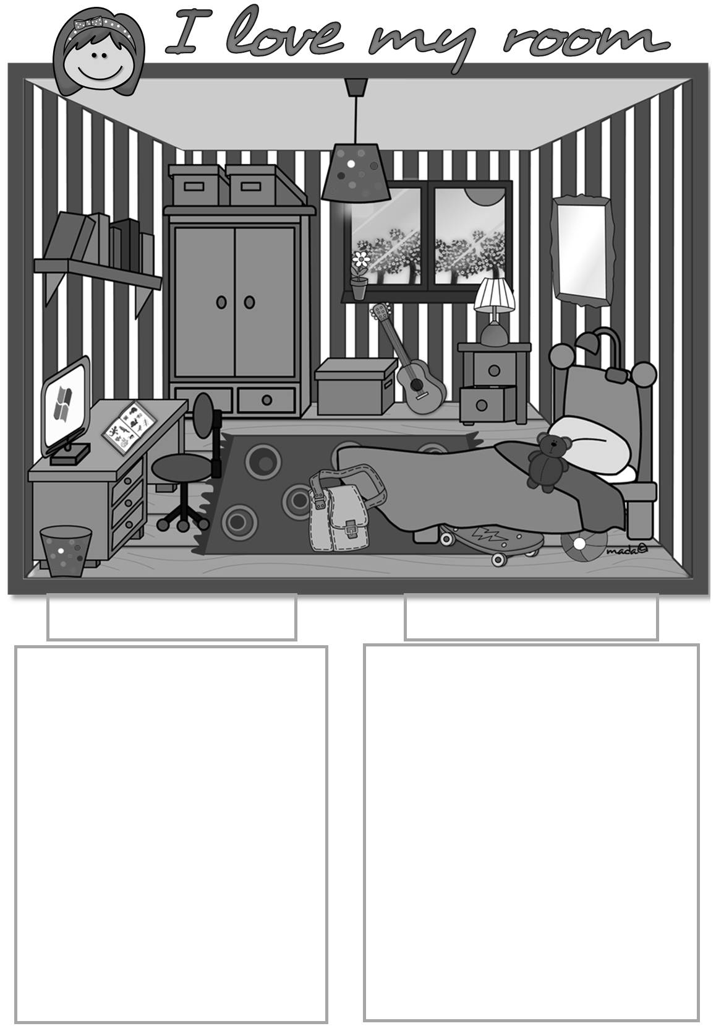
Look and fill in with There is,
There are, There isn’t, There aren’t.
________________________ a mirror.
________________________ any rollerblades.
________________________ a TV set.
________________________ some books.
________________________ a paper bin.
________________________ three boxes.
________________________ any curtains.
________________________ a football.
________________________ a schoolbag.
10. _______________________ an armchair.
11. _______________________ some toys.
12. _______________________ a bed.
13. _______________________ two lamps.
14. _______________________ any rubbish.
______________________ a rug?____
______________________ any notebooks?____
______________________ a kite?____
______________________ computer?____
______________________ any posters?____
______________________ a chair?____
______________________ a wardrobe?____
______________________ any pictures?____
______________________ a clock?____
10. _____________________ scooter?____
11. _____________________ any plants?____
12. _____________________ any drawers?____
13. _____________________ a shelf?____
14. _____________________ a teddy?____

Fill in with Is there, Are there and
answer Yes or No.

