
Do you like apples?
__________________________________________________________________
Do you like chicken?
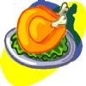______________________________________________________________
Do you like peas?
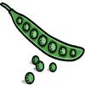________________________________________________________________
Do you like coffee?
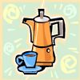__________________________________________________________________
Do you like cheese?
__________________________________________________________________
Do you like burgers?
__________________________________________________________________
Do you like ice-cream?
__________________________________________________________________

