Name: ______________________________________

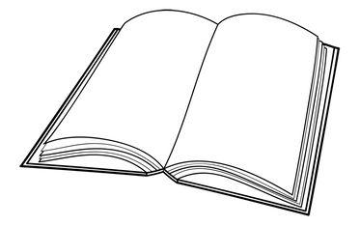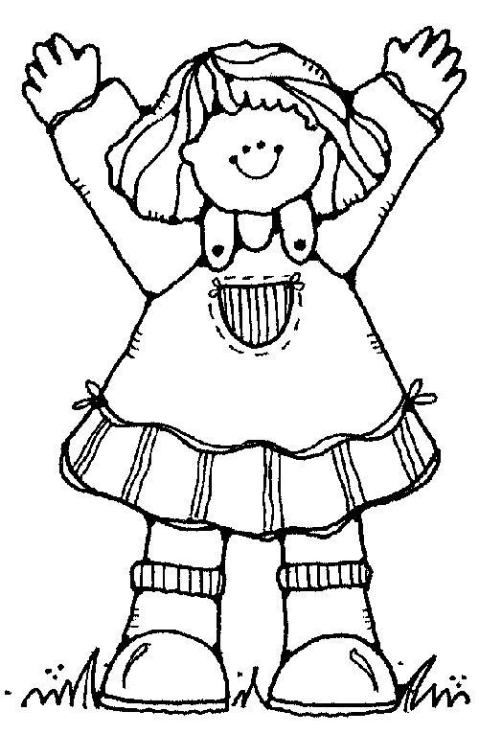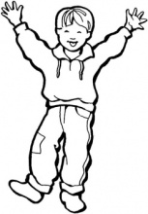

he she it

(a boy) (a girl) (a thing)

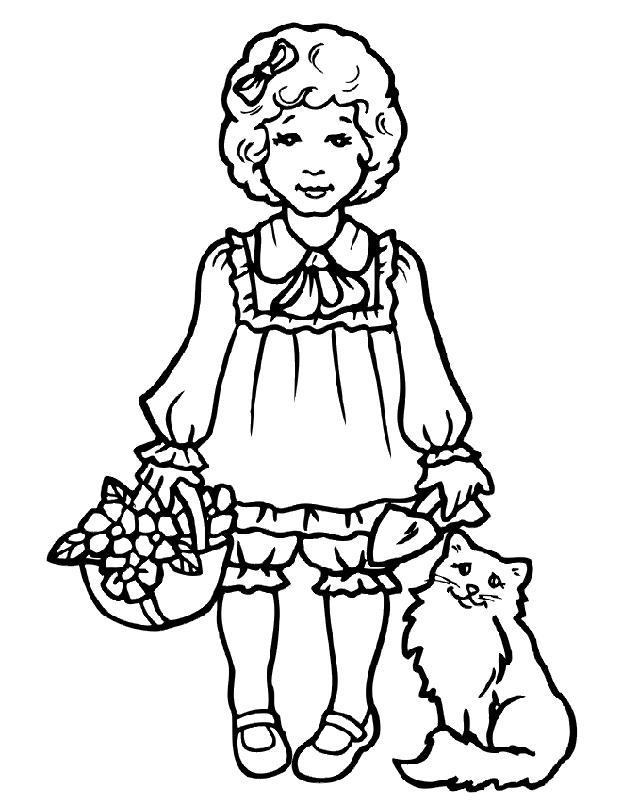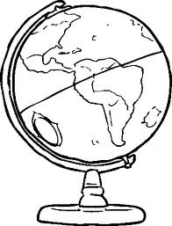

__________ is going to school. __________ is a globe. __________ has a cat.

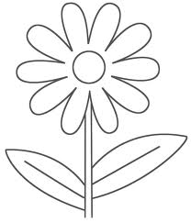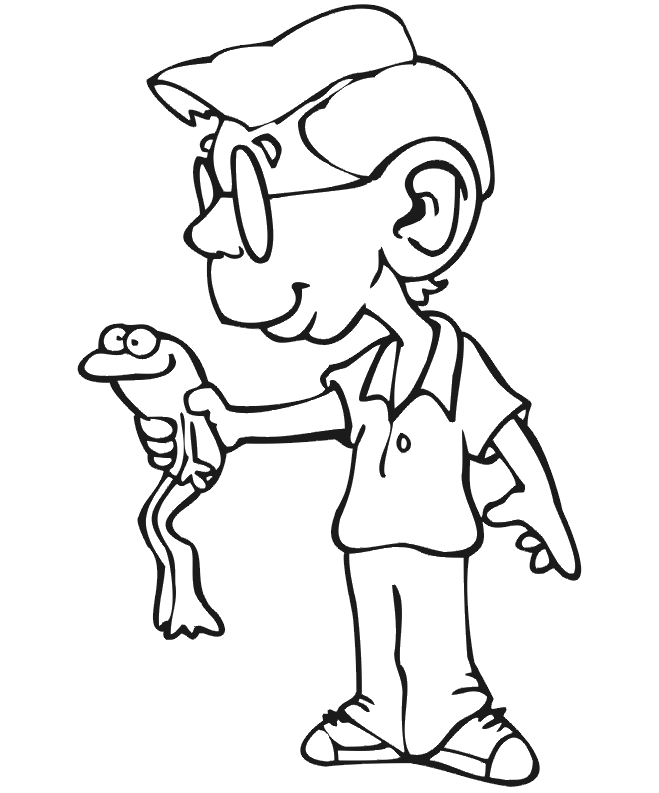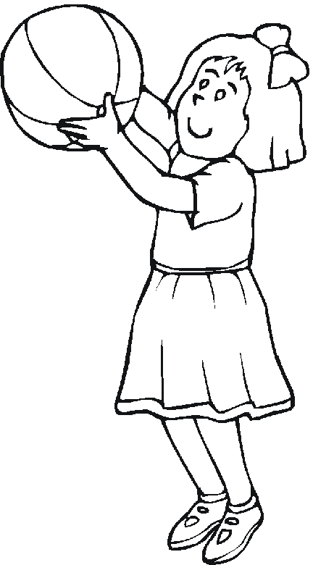

__________ is playing ball. __________ likes frogs. __________ is a flower.

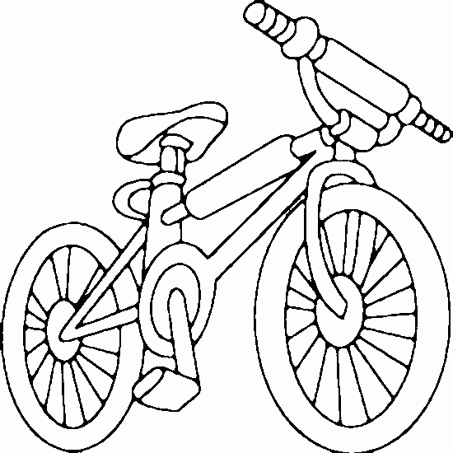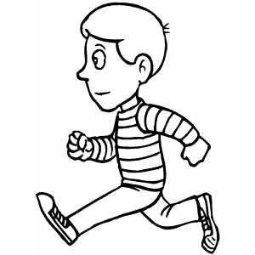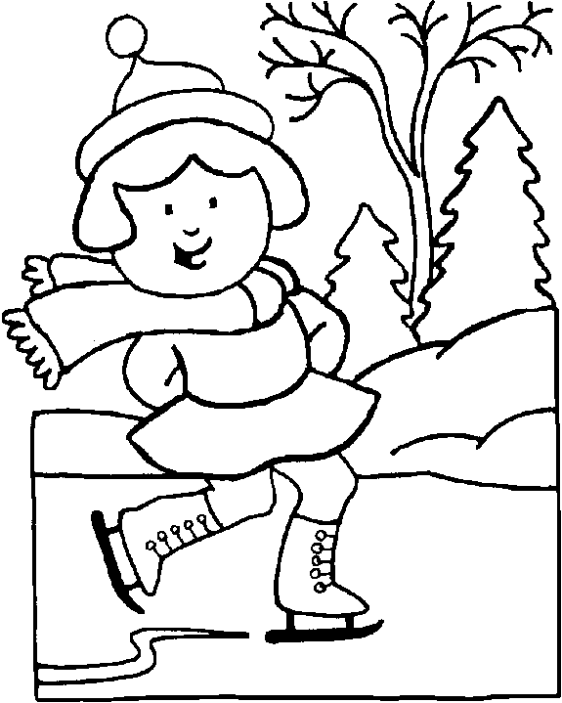

__________ is my bike. __________ is running. __________ is skating.