Mr Bean Episode the Capers
http://www.youtube.com/watch?v=YcD0Xp2iNzors

Write can or can’t
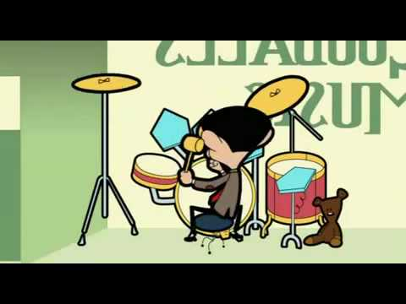 Mr Bean __________ play drumps
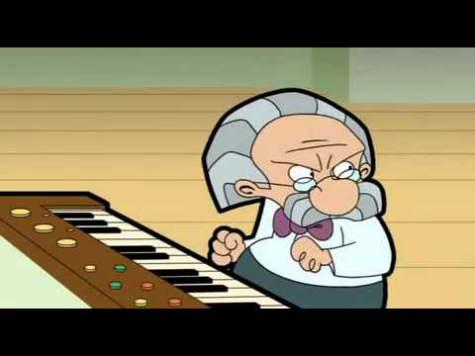 He __________ play the piano.
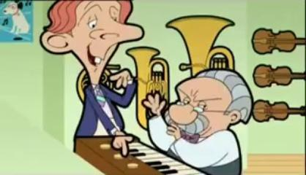 They _______ play flute.
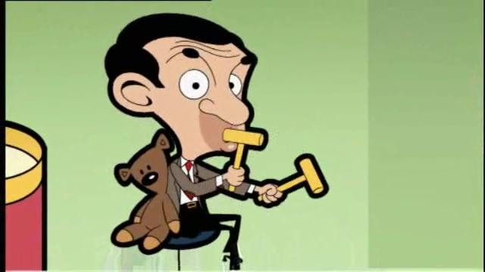 Mr Bean __________ play maracas.
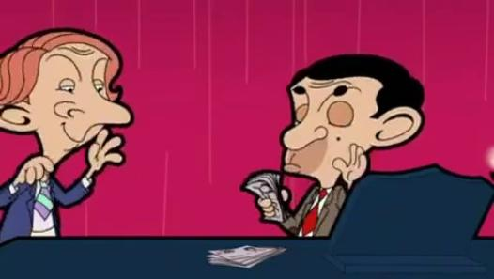 They _________ buy a piano.

