Subject pronouns: **I / you/ he /she/ they**



**I**



**He**



**You**



**She**

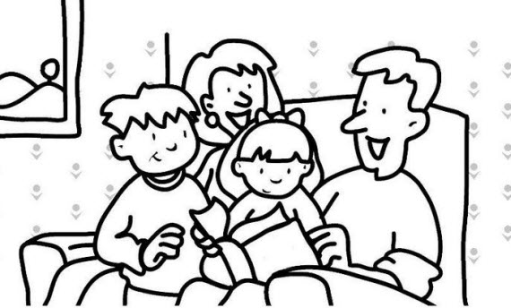

**They**

**Write: *He*** or ***she***

1.  **_________ 3. _________**

**2. _________ 4. _________**

**5. _______ 10.** **_______**

**6. _______ 11. _______**

**7. 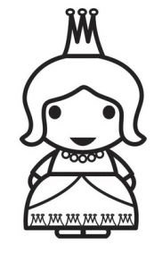_______ 12.** **_______**

**8. _______ 13.** **_______**

**9.  _______ 14. _______**