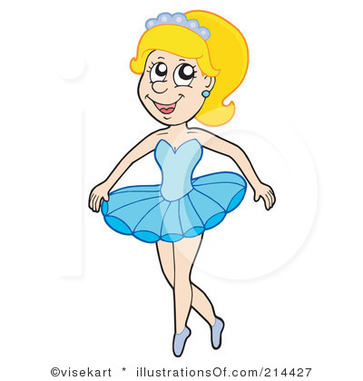

***I am Anna.***

***I am a ballerina.***

***I am not a teacher.***

***I am seven. I am not five.***

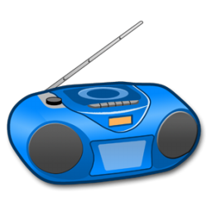

***It is a radio.***

***It is not a TV.***

***It is blue.***

***It is not black.***

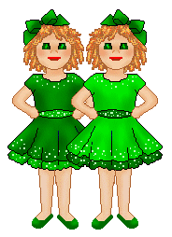

***They are twins.***

***They are sisters.***

***They are not brothers.***

***They are Kate and Jane.***

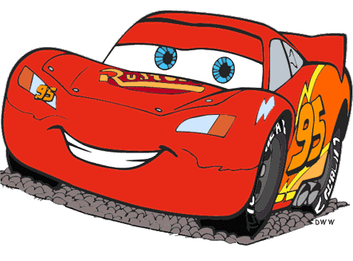

***It ____ a car.***

***It ____ _____ a plane.***

***It ____ red.***

***It ____ _____ black.***



***It ____ a cake.***

***It ____ _____ a lemon.***

***It ____ pink.***

***It ____ _____ blue.***

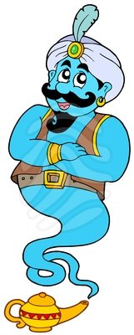

***He ____ a genie.***

***he ____ ____ a boy.***

***He ____ blue.***

***He ____ _____ red.***

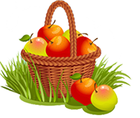

***They _____ apples.***

***They ____ _____ oranges.***

***They _____ red and yellow.***

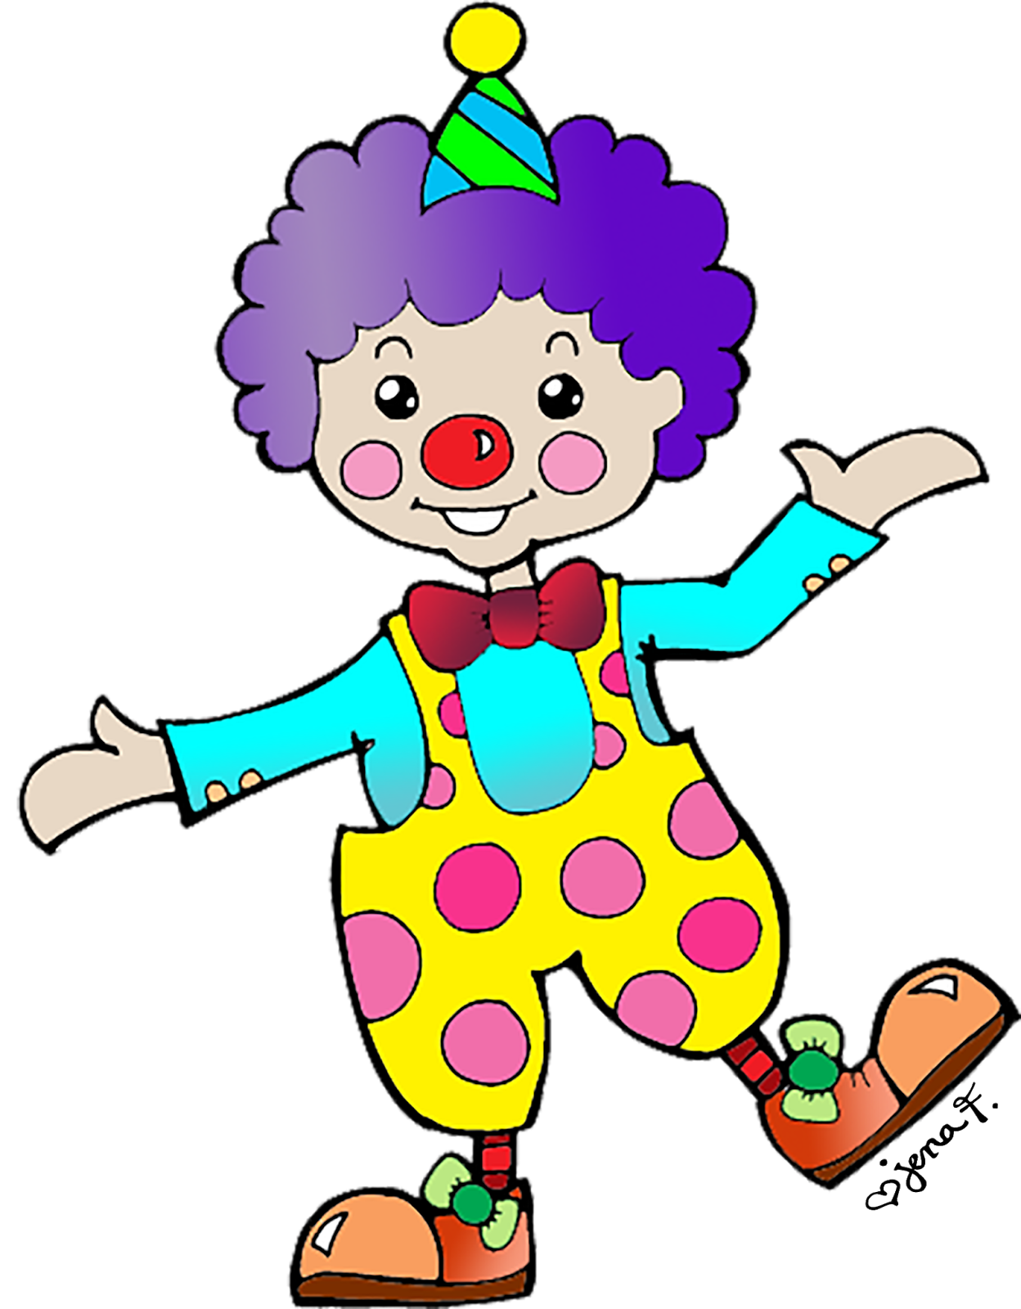

***He _____ Tom.***

***He _____ a clown.***

***He ____ _____ a genie.***

***He _____ ten. He _____ ______ eleven.***

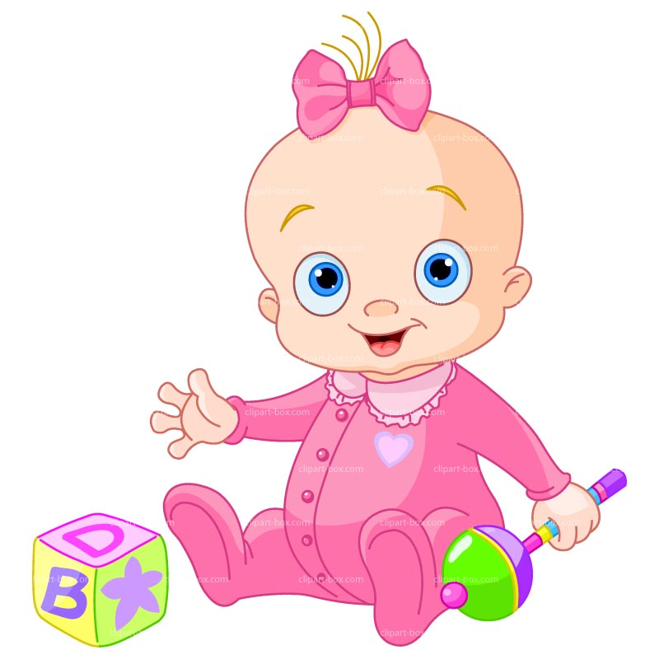

***She _____ Emma.***

***She _____ a baby.***

***She ____ _____ a doll.***

***She _____ one.***

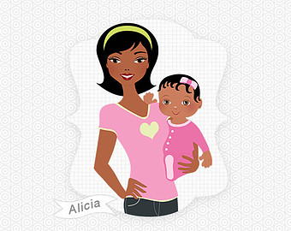

***She _____ Amelia.***

***She _____ a mother***

***She ____ _____ a father.***

***She _____ nice.***

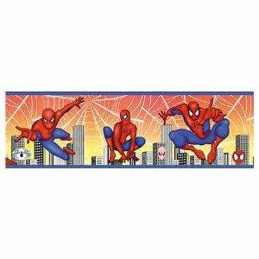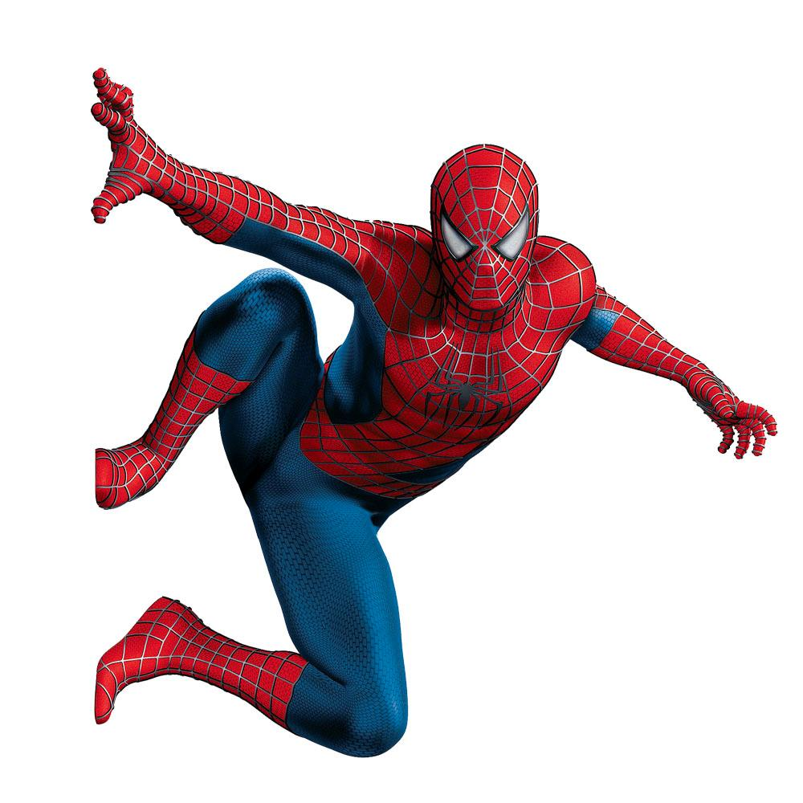

***Is he a Spiderman?***

***Yes, he is. He is a Spiderman.***

***Is he a doctor?***

***No, he is not. He is not a doctor.***

***She _____ one.***

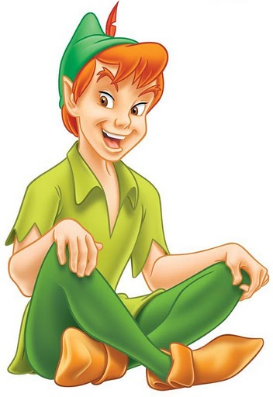

***Is he Peter Pen?***

***Yes, _____ ____. _____ _____ __________.***

***Is _____ Aladdin?***

***No, _____ _____ ______. He _____ not Aladdin.***

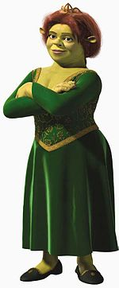

***Is she Fiona?***

***Yes, _____ ____. _____ _____ __________.***

***Is _____ Winx?***

***No, _____ _____ ______. She _____ not Winx.***

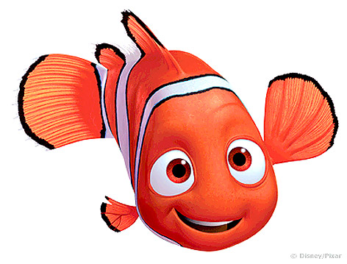

***Are they Nemo and Flounder?***

***Yes, _____ _____. They _____ __________ and Flounder.***

***_____ they Shrek and Donald?***

***No, _____ _____ ______. They _____ not _______ and Donald. They are fish.***