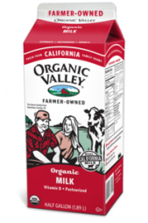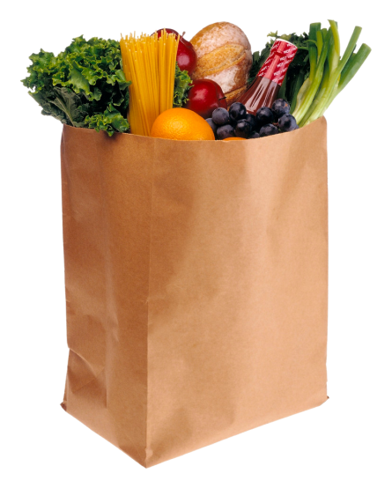

**5**

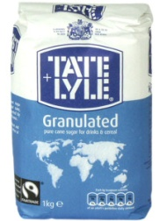

**2**

**A box of cereal**

**A carton of milk of ketchup**

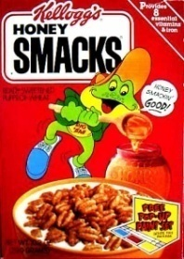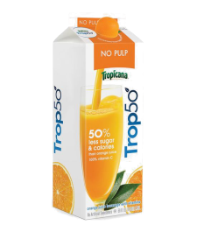

**3**

**A container of yoghurt of ketchup**

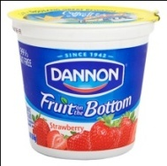

**1**

**4**

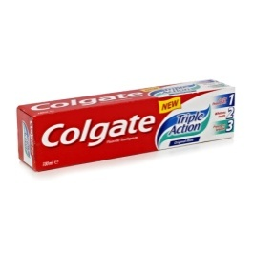

**A bag of sugar**

**7**

**A carton of juice**

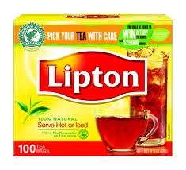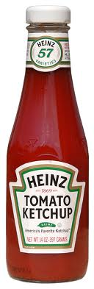

**A bottle of ketchup of ketchup**

**A tube of toothpaste of ketchup**

**8**

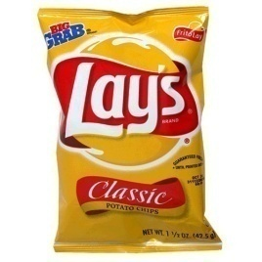

**9**

**6**

**A box of tea bags**

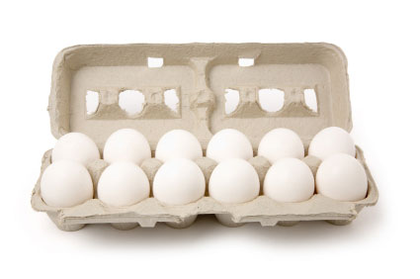

**A loaf of bread of ketchup**

**100**

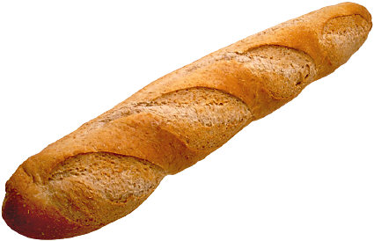

**A carton/dozen of eggs of ketchup**

**A bag of potato chips**

**A bottle of olive oil of ketchup**

**112**

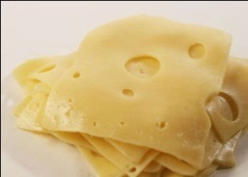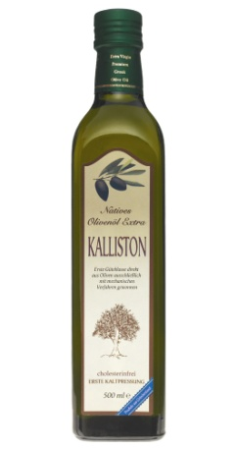

**15**

**13**

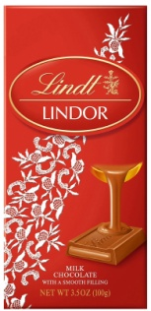

**14**

**120**

**A bunch of bananas**

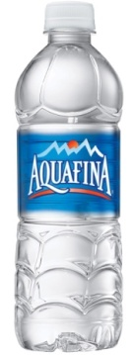

**16**

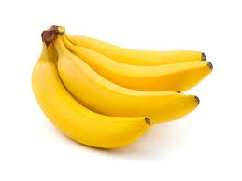

**Slices of cheese of ketchup**

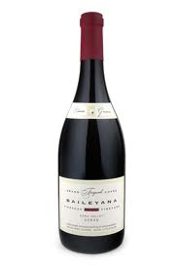

**17**

**A bar of chocolate**

**20**

**A bottle of water of ketchup**

**A bottle of wine of ketchup**

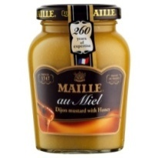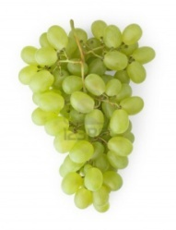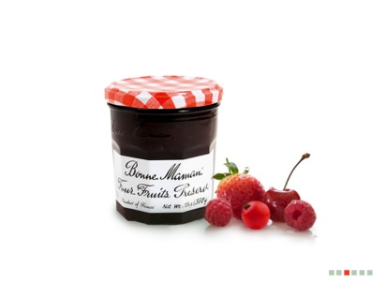

**18**

**A bunch of grapes of ketchup**

**A jar of mustard**

**19**

**A jar of jam of ketchup**