
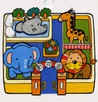
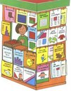



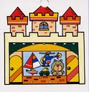

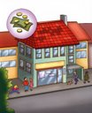
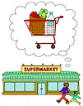

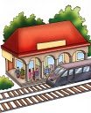
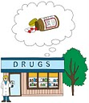

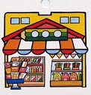

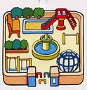

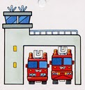
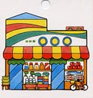




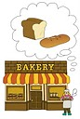

COMPLETE THE WORDS AND FIND THEM IN THE WORDSEARCH

B_ _ _ _’_ B_ _ _ _ _ _ _ P_ _ _ L_ _ _ _ _ _
O_ _ _ _ _

P_ _ _ _ _ C_ _ _ _ _ R_ _ _ _ _ _ _ _ _ Z _ _
O_ _ _ _ _

H_ _ _ _ _ _ _ G_ _ _ _ _’_ F_ _ _ S_ _ _ _ _ _ S_ _ _ _ _

P_ _ _ _ _ _ _ _ _ C_ _ _ _ _ S_ _ _ _ _ _ _ _’_ C_ _ _ _ _
S_ _ _

N_ _ _ _ _ _ _ _’_ C_ _ _ _ _ _ R_ _ _ _ _ _ M_ _ _ _ _
S_ _ _ _ _ _

S_ _ _ _ _ _ _ _ _ _ B_ _ _ G_ _ _ _ _ _ _ _ _ _’_ T_ _
S_ _ _
WORDSEARCH
S | C | H | O | O | L | R | P | E | A | O | T | R | C | D
R | R | S | O | B | A | N | K | R | I | O | U | O | S | N
L | A | T | I | P | S | O | H | I | C | A | N | T | L | U
G | S | R | E | N | O | I | T | A | T | S | S | N | I | O
C | H | E | M | I | S | T | S | S | R | E | K | A | B | R
S | U | P | E | R | M | A | R | K | E | T | E | R | R | G
T | N | O | I | T | A | T | S | E | R | I | F | U | A | Y
N | O | I | T | A | T | S | Y | A | W | L | I | A | R | A
E | C | L | O | T | H | E | S | S | H | O | P | T | Y | L
G | I | I | O | S | E | C | I | F | F | O | T | S | O | P
A | N | N | Z | R | N | I | N | G | R | O | C | E | R | S
S | E | N | B | S | A | L | I | E | C | H | U | R | C | H
W | M | S | R | E | C | O | R | G | N | E | E | R | G | L
E | A | R | O | B | O | P | O | H | S | K | O | O | B | E
N | T | O | Y | S | H | O | P | M | U | S | E | U | M | B

1-…………… 7-…………… 13-…………… 19-…………..
2-………….. 8-………….. 14-………….. 20-…………..
3-………….. 9-………….. 15-………….. 21-…………..
4-…………… 10-………… 16-…………. 22-…………..
5-………….. 11-………… 17-…………. 23-………….
6-………….. 12-……….. 18-………….. 24-…………

READ COMPLETE AND MATCH.

1-YOU BUY V_ _ _ _ _ _ _ _ _ AT THE…………….

2-YOU SEE A_ _ _ _ _ _ AT THE……………..

3-YOU BUY N_ _ _ _ _ _ _ _ _ AT
THE……………..

A- ZOO B- GREENGROCER’S
C-NEWSAGENT’S

