**The Circus**

Read through the text about a circus, then answer the questions.

The Fellini Brothers Circus is in town! Every year, the circus arrives and stays for a week. Then they go to the next town.

There are not many animals in the circus. People told the circus that they didn't like seeing animals performing. There is an elephant called Jacob and two old lions, Hattie and Meg.

Most of the performers are human! There is Leopold “The Strongest Man in the World”. His father also worked in the circus, but Leopold is stronger than him, he has bigger arms and bigger legs too! Leopold performs his act every night for the town's people who come to watch.

Another performer is Clara. She says she has the longest hair in the world. It's about 4 metres long! She also has a daughter who works in the circus. Her name is Sue-Ellen. Her hair is a lot shorter, but she wants to grow it as long as her mother's. Sue-Ellen helps look after the animals and she's also learning how to juggle.

The highlight of the circus are the three clowns, Pit, Pot and Pat. They all wear long red shoes, but Pat's shoes are the longest and sometimes, he falls over because they're so long! They perform for about twenty minutes and they are always the most popular act with the audience, especially the children. Many people think Pit, Pot and Pat are three brothers, but Pat is older than the other two - he's their father! He's the oldest clown in the country, but he has a lot of energy.

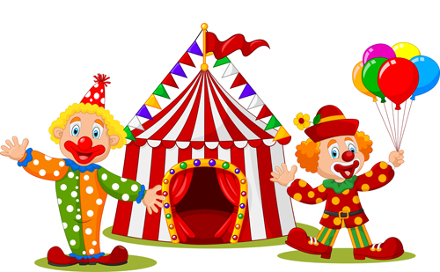

Questions

1. The circus comes to the town twice a year.

True

False

1. There are not many animals in the circus.

True

False

1. Leopold’s father is stronger than Leopold?

True

False

1. Clara has longer hair than Sue-Ellen?

True

False

1. Pot’s shoes are the longest shoes?

True

False

1. Who is the oldest – Pit, Pot or Pat?

Pit

Pat

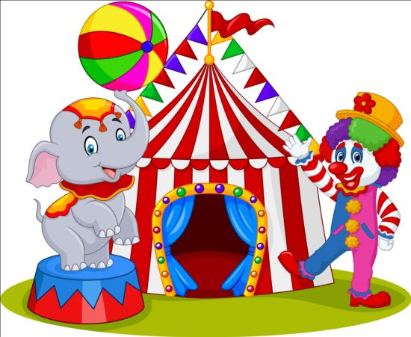Pot