

Match the actions with the pictures. Then rewrite them in the PAST SIMPLE.
EXAMPLE: Last summer I packed my bag to go camping.

19
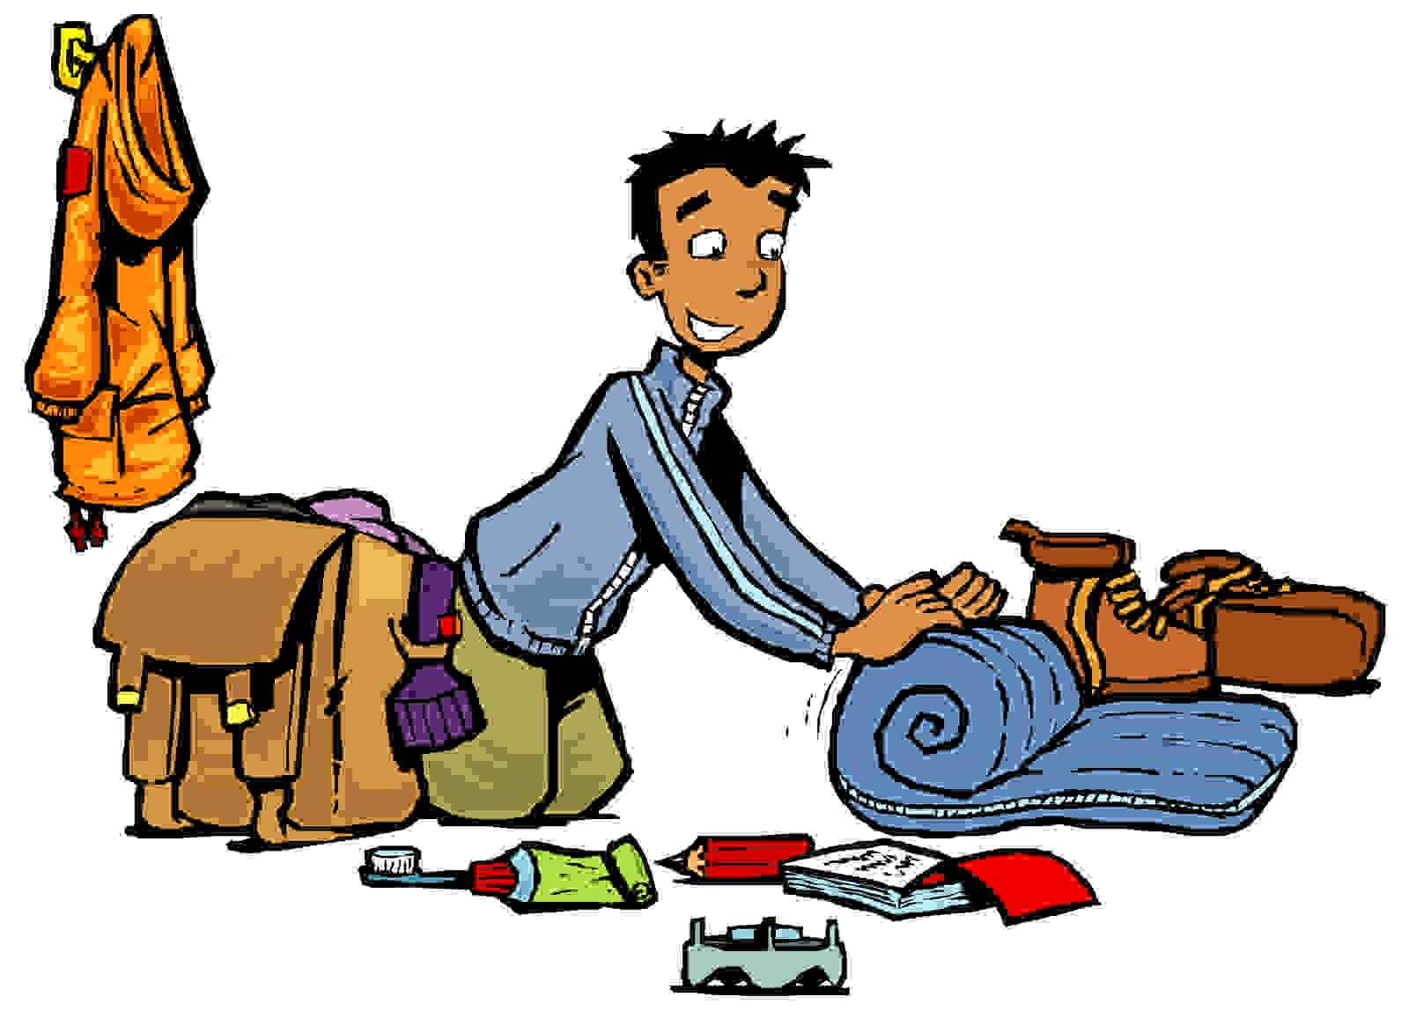
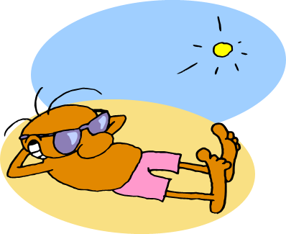
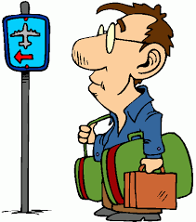

1. build a sand castle
2. hike a lot
3. learn how to scuba dive
4. travel by plane
5. read a very funny story
6. play a lot of computer games
7. eat lots of ice cream
8. spend a week in New York
9. climb a mountain
10. sunbathe on the beach every day
11. go fishing
12. surf a huge wave
13. sleep in a tent
14. drive to Italy
15. make a campfire
16. have a barbecue
17. visit a museum
18. go sightseeing on a tour bus
19. pack my bag to go camping
20. drink coconut milk
21. fly a kite
22. do lots of sports
23. roast some marshmallows
24. buy some souvenirs
25. take a lot of selfies
26. ride a roller coaster
27. stay in a 5-star hotel
28. swim in the sea

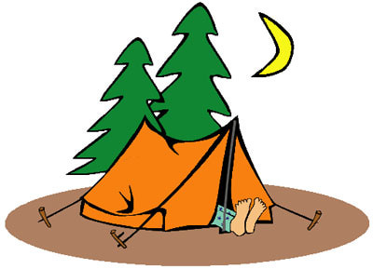
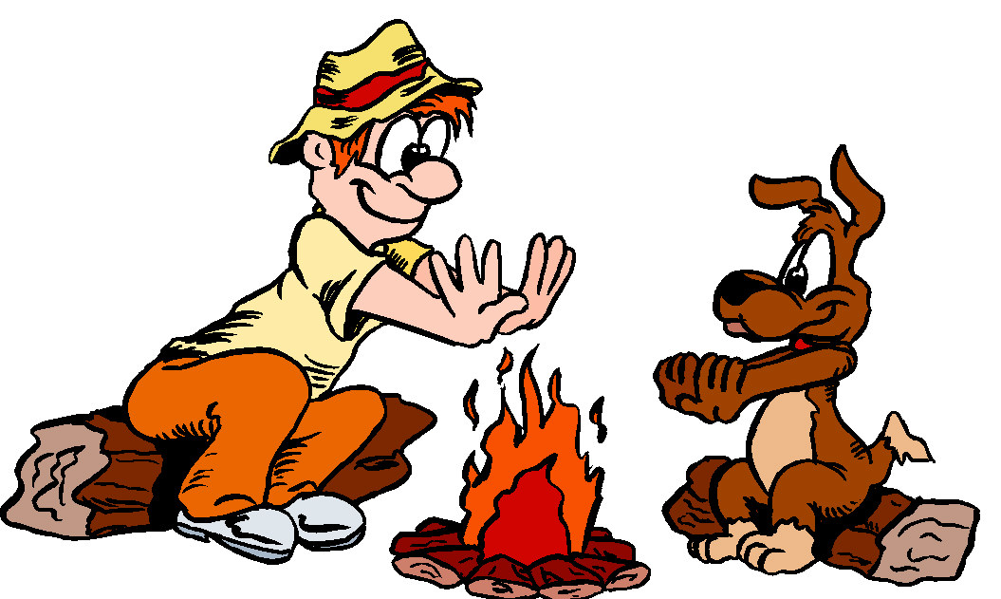



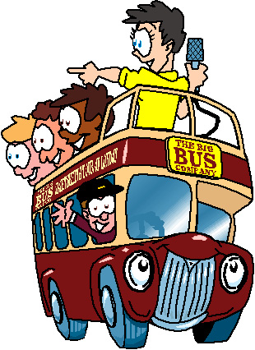
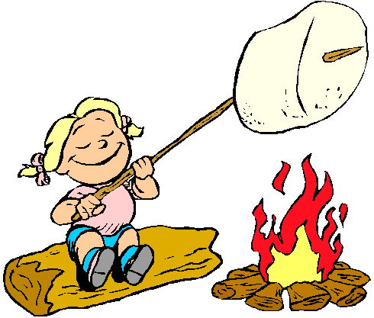
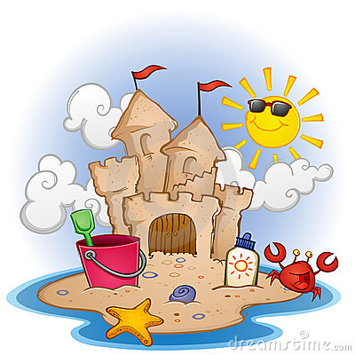
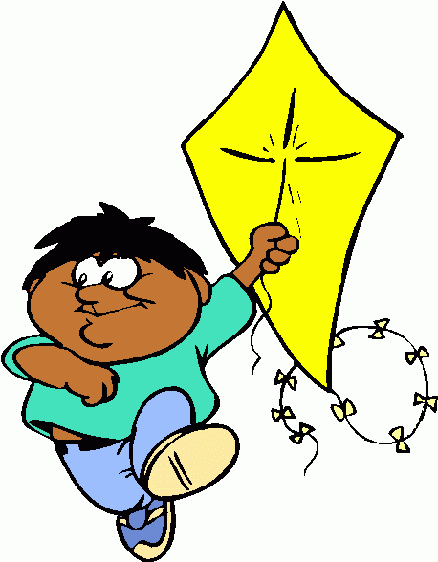

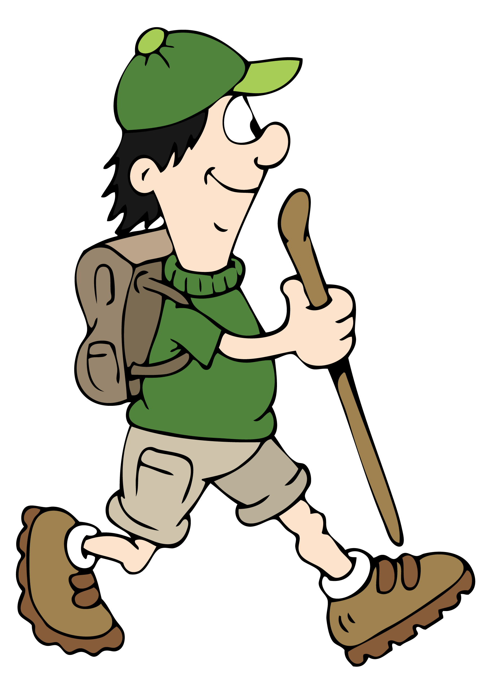
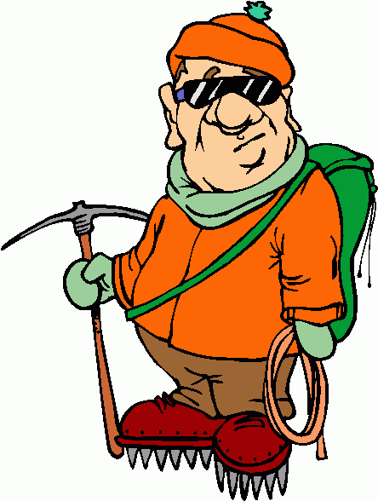
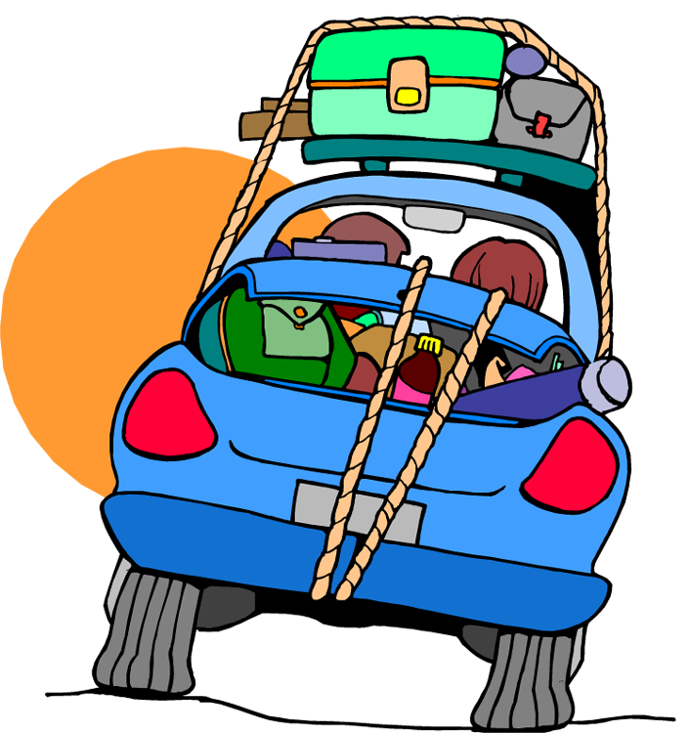


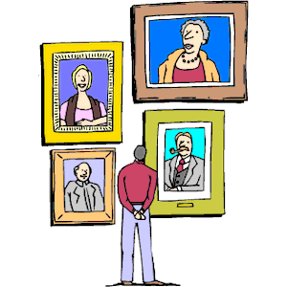


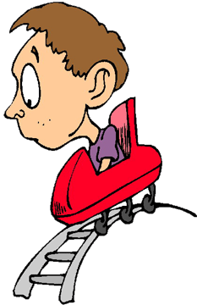

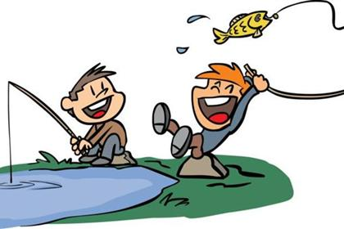
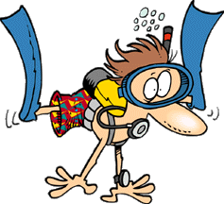



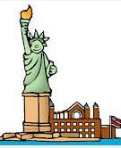
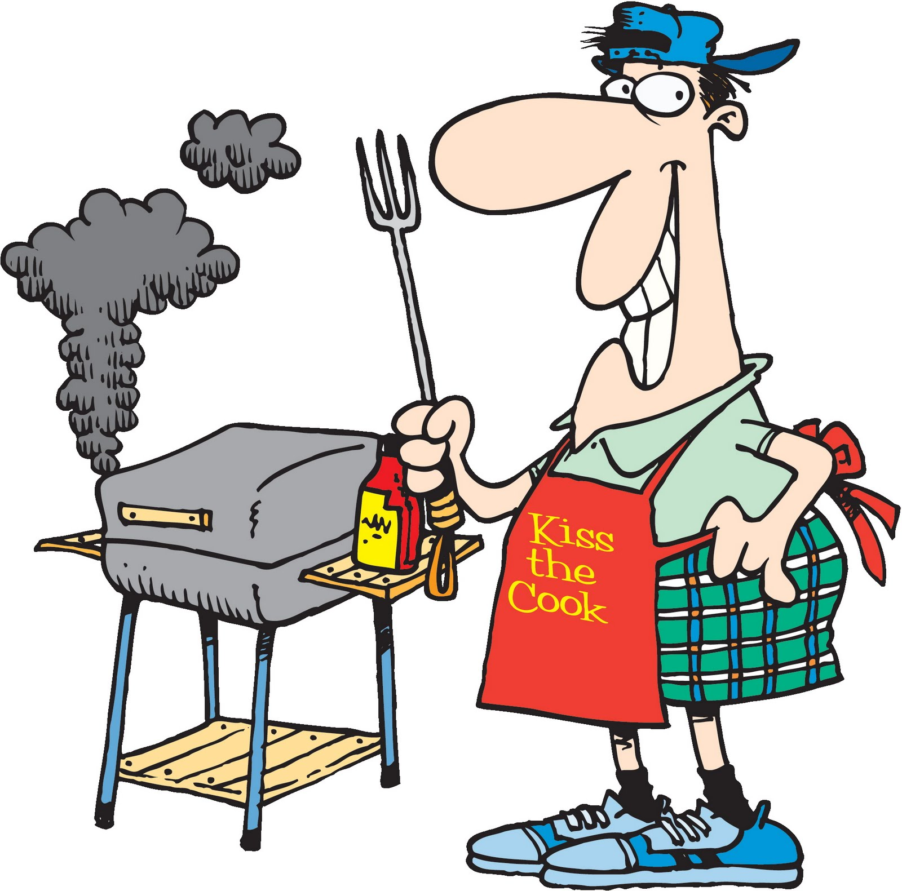
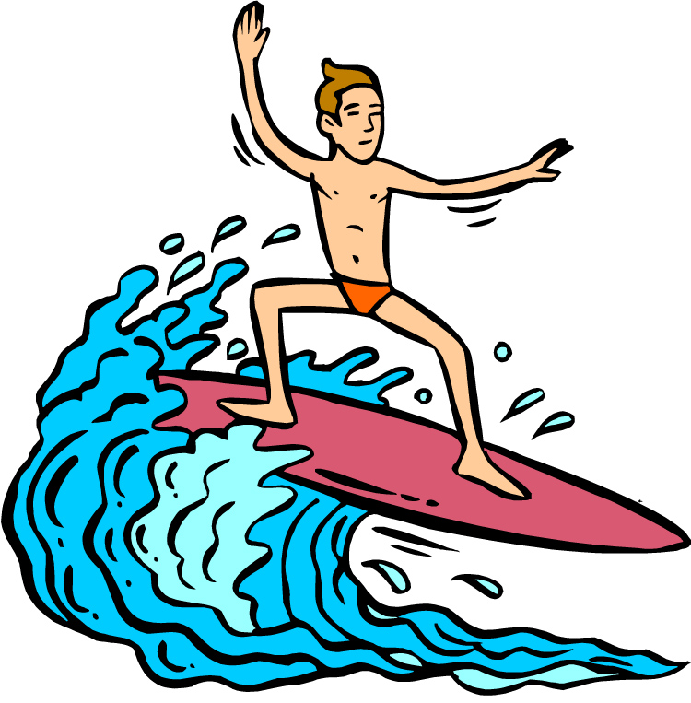


Match the actions with the pictures. Then rewrite them in the PAST SIMPLE.
EXAMPLE: Last summer I packed my bag to go camping.

19

1. build a sand castle
2. hike a lot
3. learn how to scuba dive
4. travel by plane
5. read a very funny story
6. play a lot of computer games
7. eat lots of ice cream
8. spend a week in New York
9. climb a mountain
10. sunbathe on the beach every day
11. go fishing
12. surf a huge wave
13. sleep in a tent
14. drive to Italy
15. make a campfire
16. have a barbecue
17. visit a museum
18. go sightseeing on a tour bus
19. pack my bag to go camping
20. drink coconut milk
21. fly a kite
22. do lots of sports
23. roast some marshmallows
24. buy some souvenirs
25. take a lot of selfies
26. ride my bike every day
27. stay in a 5-star hotel
28. swim in the sea

Match the actions with the pictures. Then rewrite them in the PAST SIMPLE.
EXAMPLE: Last summer I packed my bag to go camping.

19

25

10

4

1. built
2. hiked
3. learnt / learned
4. travelled
5. read
6. played
7. ate
8. spent
9. climbed
10. sunbathed
11. went
12. surfed
13. slept
14. drove
15. made
16. had
17. visit
18. went
19. packed
20. drank
21. flew
22. did
23. roasted
24. bought
25. took
26. rode
27. stayed
28. swam

7

28

15

13

21

23

18

1

14
27

9

2

17

6

26

24

3

11

5

20

22

12

8

16

